Issue: Unable to Close Dimension Dialog
Possible cause: Server Stopped or PowerOLAP Client has Lost Network Connection.
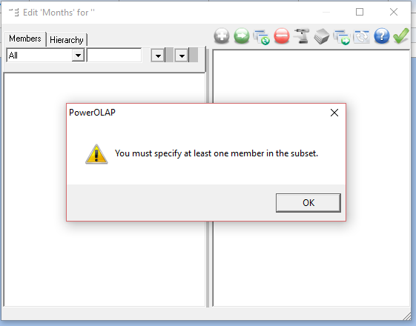
Resolution:
- Check Network Connection and PowerOLAP Server status is running.
- End process PowerOLAP Client via Task Manager and open it again.
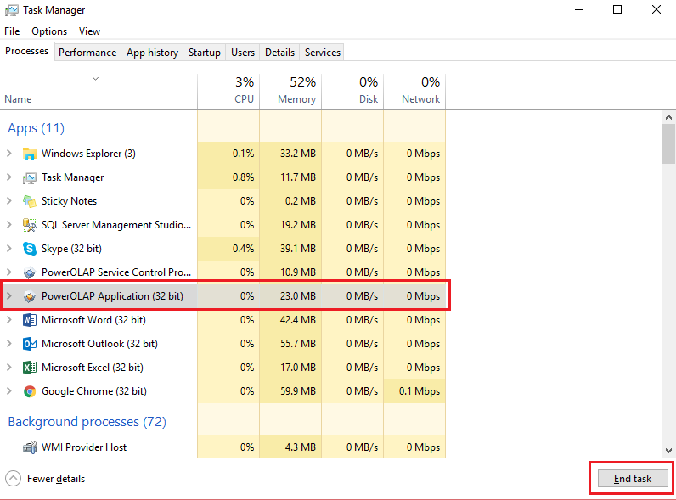
*Right click on the toolbar and select task manager for this window to appear

